Penketh South CP School



Pupil Premium Statement
December 2025

Pupil premium strategy statement

This statement details our school’s use of pupil funding to help improve the attainment of our disadvantaged pupils.

It outlines our pupil premium strategy, how we intend to spend the funding in this academic year and the effect that last year’s spending of pupil premium had within our school.

School overview
Detail | Data
School name | Penketh South Primary School
Number of pupils in school | 228
Proportion (%) of pupil premium eligible pupils | 12.7 %
Academic year/years that our current pupil premium strategy plan covers (3 year plans are recommended) | 2025-2026
Date this statement was published | December 2025
Date on which it will be reviewed | July 2026
Statement authorised by | Claire Lawton, Headteacher
Pupil premium lead | Lorraine Browne, Deputy Headteacher
Governor / Trustee lead | Pamela Lucido
Funding overview
Detail | Amount
Pupil premium funding allocation this academic year | £40,696
Recovery premium funding allocation this academic year | £3,624
Pupil premium funding carried forward from previous years (enter £0 if not applicable) | £0.00
Total budget for this academic year  If your school is an academy in a trust that pools this funding, state the amount available to your school this academic year | £44,320

Part A: Pupil premium strategy plan

Statement of intent
We believe that all of our children, regardless of their background or additional needs are entitled to a curriculum which fully meets their needs but also enriches their lives both now and in the future. All of our staff have high expectations of our children and share a commitment to improving life chances for all children. Our curriculum intent statement expands on this: -
On the children’s journey through Penketh South we aim to spark their curiosity and fire their enthusiasm. We want our children to take pride in themselves, their achievements and their environment. They will be taught to respectfully question, to show appreciation for the world around them and to accept and understand equality and diversity. We will provide opportunities for our children to develop as independent, confident and successful learners who have high aspirations for the future. The children will be encouraged and supported to become resilient learners who understand that it is ok to make mistakes as long as they use these experiences to help them to develop and grow. Our children will become learners for life, powerful contributors, confident individuals and responsible citizens of the future.
To ensure that all of our children, including disadvantaged children, make progress, we assess and evaluate the children’s needs on a regular basis using a range of assessment methodologies and make provision for them accordingly. Using this approach means that all children will benefit but that we can ensure our disadvantaged pupils are supported effectively in order to make accelerated progress where necessary, including those who are already high attainers, and therefore gaps between disadvantaged pupils and their peers should narrow.
(Disadvantaged pupils are defined as: Pupils who have been eligible for Free Schools Meals (FSM) at any point over the last 6 years, Pupils who have been looked after continuously for at least one day in the last year, and pupils who have left care through a formal route such as adoption.)
It is important that we ensure: -
- An appropriate level of challenge
- That additional scaffolding, support or intervention is provided as soon as a need is identified
- That assessment is used effectively, both formative and more standardised forms of assessment
- That we will work with appropriate agencies to identify and help support additional learning needs

Challenges

This details the key challenges to achievement that we have identified among our disadvantaged pupils.
Challenge number | Detail of challenge
1 | Many of our pupils have displayed difficulties with their emotional well-being and mental health, including anxiety-related needs. This appears to impact on many of our ‘disadvantaged’ pupils in particular. Children are identified through observation, discussion with children and from parents raising concerns.
2 | A number of our children who attract PPG struggle with forming and maintaining relationships and need support with conflict management. Again, we use pupil discussion, conversations with parents and general observations to identify children who require additional support with relationships.
3 | Some of our ‘disadvantaged’ children also have Special Educational Needs which vary in type. We use specific assessments, general assessment information as well as information from parents and professionals from external agencies using Warrington’s Graduated Response to identify need and appropriate ways of supporting our pupils.
4 | Some of our ‘disadvantaged’ children would struggle to access activities such as sports clubs, music lessons, school trips and visits, etc. without financial support. We have found that subsidising these kinds of activities in the past has ensured a broader and richer curriculum for the children. It has also allowed us to encourage children who have a talent to pursue activities which might not otherwise have been possible.
5 | Some pupils struggle with motivation and maintaining attention. This impacts on their daily work and on more formal assessments.
6 | Persistent poor punctuality/attendance has negatively impacted on the progress of identified children as they have missed important sessions of learning.
7 | Some of our PPG children, have difficulties with reading or are working below ‘average’, as identified by scores below 100 in NFER tests or children who did not meet the Reading ELG in Reception. Some of these children have poor acquisition of phonic skills.
8 | Assessments indicate that maths attainment among some disadvantaged pupils is below that of non-disadvantaged pupils especially linked to retention of times table and reasoning skills.

Intended outcomes
This explains the outcomes we are aiming for by the end of our current strategy plan, and how we will measure whether they have been achieved.
Intended outcome | Success criteria
Improved reading attainment for disadvantaged pupils | - Outcomes in formalised assessments demonstrate individual progress – e.g. moving closer to or beyond a 100 score in NFER test; improved phonic scores in phonic checks, etc.  - Progress through reading bands is evidenced  - Work in books demonstrates improved comprehension skills  - Children reading regularly in school- checking planners to check reading at home.
To achieve and sustain improved well-being for all pupils, particularly our disadvantaged pupils | - Evidence on CPOMS and in Safe and Sound meetings demonstrates an improvement in how pupils feel, interact with others, etc.  - Children are less reliant on emotional interventions  - Evidence from general observations and work in books demonstrates an improvement in social interactions, impact on daily work, mood, etc.
An increase in numbers of children (particularly our disadvantaged pupils) attending extra-curricular clubs and activities | - Numbers of children attending clubs who attract PPG funding increases.
Pupils accessing vocal and instrumental teaching increases | - Number of pupils who attract PPG funding attending vocal and instrumental teaching increases
Our disadvantaged pupils participate in trips and visits, including residential visits | - PP children participate in all trips and visits.

Activity in this academic year
This details how we intend to spend our pupil premium (and recovery premium funding) this academic year to address the challenges listed above.

Teaching (for example, CPD, recruitment and retention)
Budgeted cost: £ 33,420
Activity | Evidence that supports this approach | Challenge number(s) addressed
Purchase of standardised diagnostic assessments (NFER/Welcomm  /Dyslexia Screening) | Using diagnostic assessments allows us to identify specific gaps in knowledge both for individual pupils and for small groups / whole cohorts. This enables teaching staff to plan their teaching to target these identified needs.  Assessment and feedback | EEF (educationendowmentfoundation.org.uk) | 3, 7,8 primarily  (Also, 5 and 6)
Subscription to Supersonic Phonic Friends – a systematic synthetic phonics programme (Training for all EYFS / KS1 staff) | Ensuring that pupils have a secure understanding of phonics helps them to develop the skills to decode vocabulary easily and can help children to read with greater accuracy and fluency.  Phonics | EEF (educationendowmentfoundation.org.uk)  The reading framework | 3, 7
Subscription to Times Tables Rockstars, Numbots, Number sense and Number Stacks as an Intervention | This is an online resource which we have found beneficial for helping children to practise their multiplication tables both in school and at home  Improving Mathematics in Key Stages 2 and 3 | EEF (educationendowmentfoundation.org.uk)  The DfE non-statutory guidance has been produced in conjunction with the National Centre with the National Centre of Excellence in the Teaching of Mathematics, drawing on evidence -based approaches: -  Mathematics guidance: key stages 1 and 2 (covers years 1 to 6) (publishing.service.gov.uk)  Teacher and TA CPD included | 8
CPD for Mental Health Lead (and subsequently for all staff) on how to use curriculum time to be spent on teaching regulation and identifying behaviours for resilience including KidSafe resources to enhance our PSHE provision | https://www.kidsafeuk.co.uk/wp-content/uploads/2020/10/How-KidSafe-helps-your-school-meet-statutory-requirements.pdf  This document demonstrates the many benefits of using KidSafe. It is a child-friendly approach to teaching children about safeguarding issues, including positive and healthy relationships  https://myhappymind.org/about | 1, 2
Teaching Assistants | Our teaching assistants work flexibly to allow teachers to direct teaching to specific groups of children. This has worked effectively for us in the past and we have seen individual children make progress towards their targets as a result.  Teaching Assistant Interventions | EEF (educationendowmentfoundation.org.uk) | 3, 5, 7, 8

Targeted academic support (for example, tutoring, one-to-one support structured interventions)
Budgeted cost: £ 10,900
Activity | Evidence that supports this approach | Challenge number(s) addressed
Emotional health and well-being interventions for individual pupils and small groups | There is extensive evidence associating childhood social and emotional skills with improved outcomes at school and in later life (e.g., improved academic performance, attitudes, behaviour and relationships with peers):  EEF_Social_and_Emotional_Learning.pdf (educationendowmentfoundation.org.uk) | 1, 2 primarily  (Also 5,6, 7, 8)
ELSA training  (Emotional Literacy Support Assistant)  (6-day training)  Additional member of staff trained  Dedicated pastoral support lead (ELSA) | This programme is designed to support the emotional needs of our pupils from within our own resources. This is achieved by training teaching assistants so that they can develop and deliver individualised support programmes to meet the emotional needs of children  Evaluation Reports – ELSA Network  ELSA support  Schools Mental Health Link Team Practitioner  https://myhappymind.org/about | 1,2
Drawing and Talking | Drawing and Talking Therapy is the number one alternative to CBT and direct talking therapies, that can often be confronting or limiting in the processing of pain or trauma | 1,2,3
Additional phonic sessions | Phonics approaches have a strong evidence base indicating a positive impact on pupils, particularly from disadvantaged backgrounds. Targeted phonics interventions have been shown to be more effective when delivered as regular sessions over a period up to 12 weeks:  Phonics | Toolkit Strand | Education Endowment Foundation | EEF | 3, 7
Forest School Sessions | Forest school sessions are planned with specific pupil needs in mind and focus on social interaction, communication skills, emotional regulation and collaborative work.  The Benefits of Forest School | 1,2,3,5,

Wider strategies (for example, related to attendance, behaviour, wellbeing)
Budgeted cost: £4,750
Activity | Evidence that supports this approach | Challenge number(s) addressed
Working with external agencies such as Attendance and other Early Help agencies to support families | Working Together to Safeguard Children (2018) outlines the importance of Early Help and the benefit that providing Early Help and agencies working together can have on children’s outcomes. | All challenge areas potentially
Subsidised access to trips / visits and other wider curriculum opportunities | We have previously used funding to pay for attendance at clubs, for instrumental teaching, etc. and seen the benefit that this has had on individual children (as evidenced in previous reviews). We also know that the cost of attending a residential trip, for example, can be prohibitive and so feel that subsidising this additional cost can allow all children to attend and benefit from this kind of activity. | 4
Funding for clubs such as music and sport activities to ensure that every child is | Supporting inclusivity throughout the school | 4
Engage in My Happy Mind to support identified pupils in school | Supporting work in personal development and PSHE curriculum and research completed ViaVita where it is found that 1 in 10 children have a mental health condition.  . | 1, 2
School uniform subsidy | Ofsted research (2019) places an emphasis on improving cultural capital, particularly for disadvantaged pupil and it is important that all children are able to take a full part in school life. | N/A
Embedding principles of good practice set out in the DFE’s Improving School Attendance advice. | DFE guidance has been informed by engagement with schools that have significantly reduced levels of absence and persistent absence. | 6

Total budgeted cost: £ £44,320

Part B: Review of outcomes in the previous academic year

Pupil premium strategy outcomes
Please see separate document on our school website which details the evaluation of the 24-25 Pupil Premium strategy.
Academic Performance- 2024/25 for pupils in receipt of Pupil Premium
The performance of Pupil Premium children is closely monitored and consideration is given to how we can best support pupils to raise attainment and progress.
Reception-
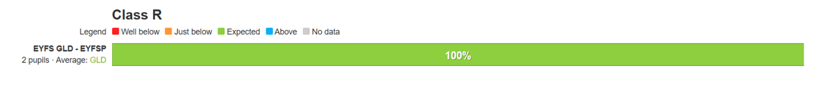
Out of Reception, there were 2 children and they both achieved their GLD.

Year 1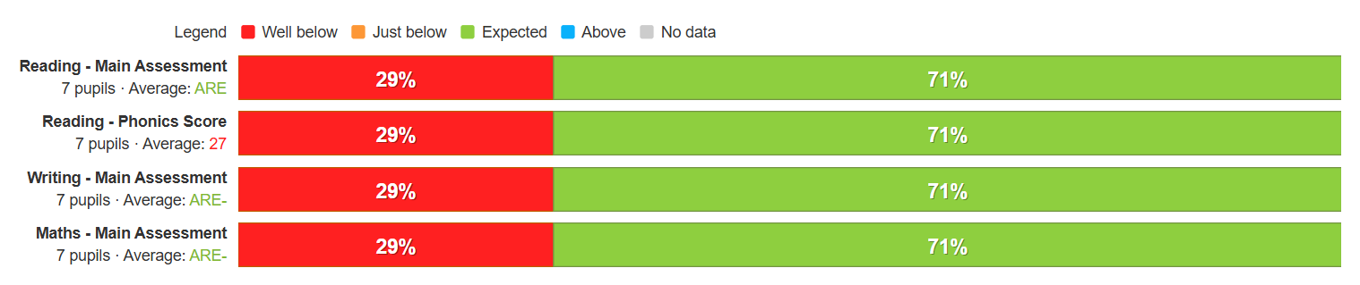
Significant number of PP within this cohort compared to others. Targeted support for this cohort due to number of SEND children also in this class. Targeted support for this cohort moving into Y2.

Year 2
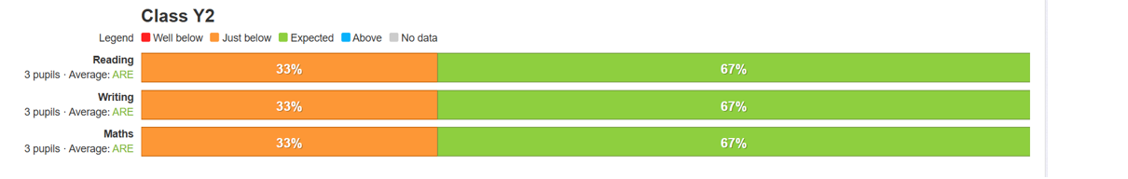
Small number of PP children in this cohort. Careful monitoring as these children move into Key Stage 2.

Year 3
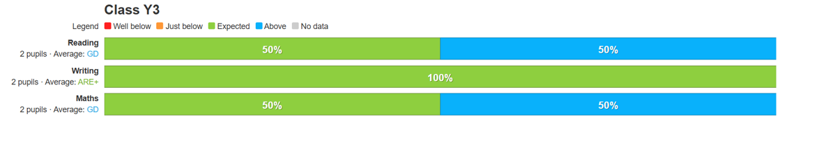
Small number of PP children in this cohort. One child has EAL.

Year 4
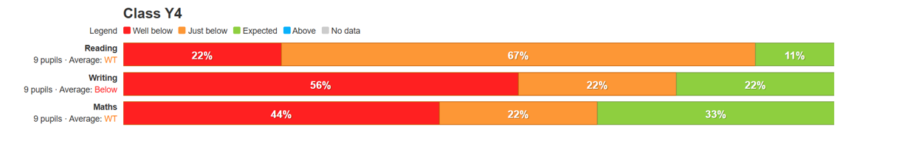
Significant number of PP within this cohort compared to others. Targeted support for this cohort due to number of SEND children also in this class. Targeted support for this cohort moving into as they move into Upper Key Stage 2 especially in Writing.

Year 5
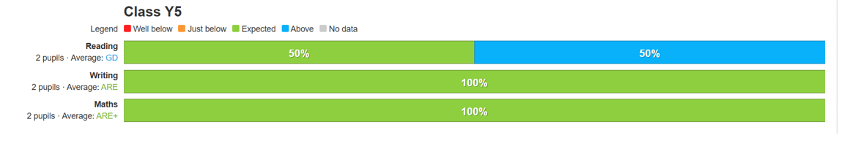
Small number of PP children in this cohort. Both children achieved Expected as well one child achieved Greater Depth in reading. Secure and expected to achieve well in SATs in year 6.
Year 6
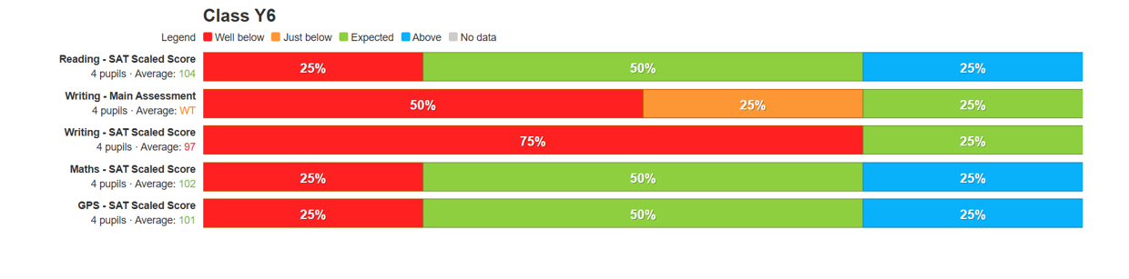
There were 4 children in this cohort. One child achieved Greater Depth in reading, maths and GPS. One child was on the SEND register.
Wider Enrichment:
All Pupil Premium children in Year 6 were able to partake in the residential in the Lake District- including all PP children accessing residentials in Y4. Some of the Pupil Premium children also accessed the trip to Denmark, through the Turing project. We are committed to enriching the cultural capital of our PP children and this remains a focus as we try to ensure that our disadvantaged and wider children have the experience of a curriculum beyond just academic subjects. We are committed in providing music tuition to children, either individually or in groups from an external teacher.
Attendance:
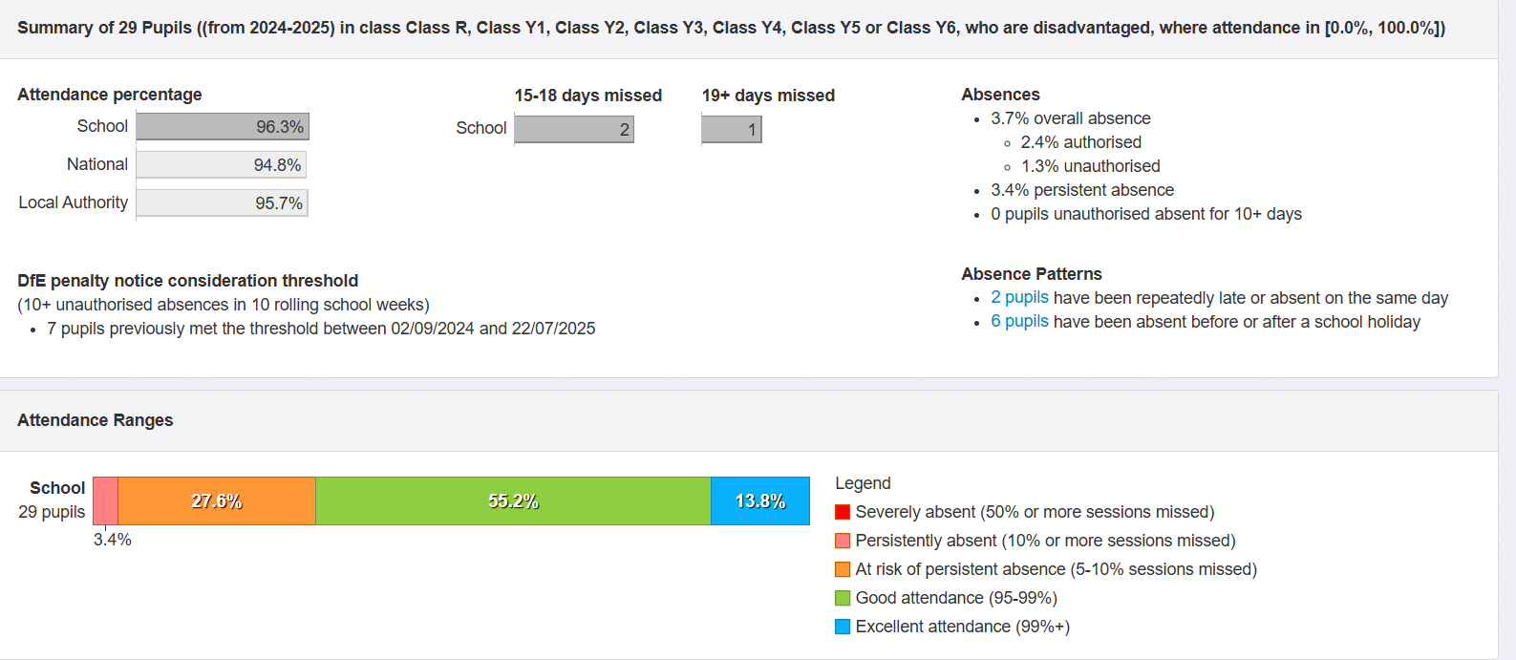
Data show that PP children’s attendance is above national and LA. Attendance data is monitored closely each day by our pastoral lead, school admin and the HT. There are regular meetings between the local attendance officer for those persistence absence.
SEMH Support:
During 2024-25, 19 disadvantaged pupils received some support from the SEMH TA’s/Counsellor/ Mental Health Team. This has a positive effect on these children. We also make utilise of School Link Mental Health Worker and Counsellor.

Externally provided programmes
Please include the names of any non-DfE programmes that you purchased in the previous academic year. This will help the Department for Education identify which ones are popular in England

Programme | Provider
Learning by Questions/Wayfinder | Learning by Questions
Phonics | Supersonic Phonic Friends
My Happy Mind | NHS
Welcomm | GL Assessment
Nessy | Nessy Learning
Emile | Webskape Ltd

