Penketh South Primary School – Special Educational Needs Information Report – 2023-24
‘Do your best….Be your best’

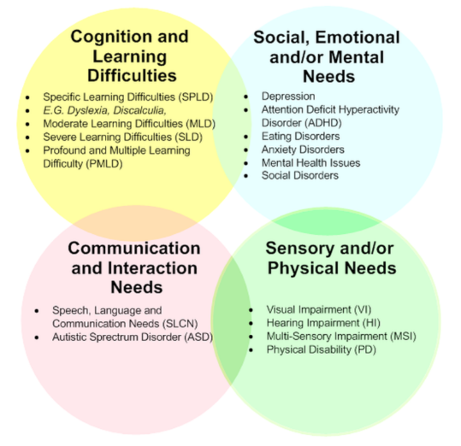  - Kinds of Special Educational Needs that are provided for at Penketh South Primary School. | At Penketh South Primary School we provide support for pupils across the four areas of need, as stated in the 0-25 SEND Code of Practice 2015:  - Communication and Interaction  - Cognition and Learning  - Social, Emotional and Mental Health difficulties  - Sensory and/or Physical needs  Where dedicated provision for an individual child is required, an EHCP (Educational Health Care Plan) will be provided. This follows a formal assessment by the Local Authority and outside agencies, to assess the child’s needs and specific criteria are written to create the plan.  Children identified in school as having SEND and have outside agencies supporting provision, are placed on the SEND register. This is reviewed termly.  School Support is for children with identified needs, who are catered for by school provisions.
- Information about the school’s Policies for identification and assessment of pupils with SEN. | Pupils are identified as having SEN and their needs assessed through:  - Information passed on from Nursery, classes and previous schools.  - KS1 results, baseline testing and progress data  - Concerns raised by teaching staff  - Feedback from teaching staff and observations  - Pupil Premium interventions not showing impact  - Referrals or concerns from parents  - Reports from external agencies or professionals such as: paediatrician, speech and language therapist, health visitor, educational psychologist  - School’s formative and summative assessment data
3a. Evaluating the effectiveness of the provision made for pupils with SEN | Pupils’ learning and progress is tracked continuously through varied assessment for learning strategies. There are also formal assessment points within the year when progress in also analysed. Adaptations to provision are planned in year group pupil progress meetings, which are held with the Headteacher and SENDCo. Where interventions are necessary, individual or group intervention plans are written and delivered by teachers and TAs. A graduated approach cycle of assess, plan, do and review occur at least termly, examining the effectiveness and impact of provision.  Progress and evaluations are reported to the Governing body and the Governor with responsibility for children with SEND.  The SEN Information Report is posted on our school website.
3b. Arrangements for assessing and reviewing pupils’ progress towards outcomes, including opportunities available to work with parents and pupils as part of this assessment and review.  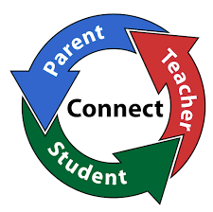 | These arrangements include:  • Graduated approach (Assess-Plan-Do-Review)  • Tracking of assessment data for pupil progress  • Intervention reviews  • ECHP reviews, at least annually (For children in EYFS this will be bi-anually)  • Observations of pupils  • Analysing the impact of interventions  • Parent’s evenings  • School reports  • Open door policy
3c. The school’s approach to teaching pupils with SEN | Provision for SEN pupils includes:  - Quality first teaching, with appropriate differentiation and challenge in place for groups and individuals  - Following a graduated approach (assess, plan, do and review)  - Effective provision management including the deployment of Teaching Assistants (TAs)  - Using a person-centred approach  - Appropriate use of classroom-based interventions  - Availability of quality resources  - Working closely with parents and carers, including regular meetings and updates  - Teaching Assistant support  - Intervention Planning  - Health Care Plans may be written for children with physical disabilities  - Referrals to outside agencies and following advice given  - Personalised provision through adapted resources and interventions.  - Application for top-up funding either via EYSENDIF or an Education, Health and Care Plan.  - An EHCP planning meeting is held with an EHCP co-ordinator for the school in the Autumn term.
3d. How adaptations are made to the curriculum and the learning environment of pupils with SEND  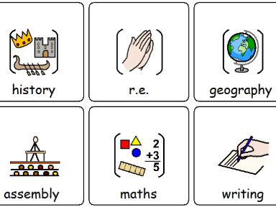 | The curriculum /learning environment may be adapted by:  - Groupings that target specific levels of progress  - Differentiated resources (writing frames, word mats, coloured overlays etc) and teaching styles  - Appropriate choices of texts and topics to suit the learner  - Additional adult support  - Displays and working walls that enhance learning  - Access arrangements for tests.
4. How school enables pupils with special educational needs to engages in the activities of the school; increasing the extent to which disabled pupils can participate in the curriculum  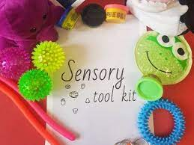 | Penketh South Primary School is highly committed to inclusion and equal opportunities. Our Equality Policy and Plan is available on the website. In July 2023 we achieved the ‘Committed to Inclusion Mark’ to demonstrate our ongoing commitment to inclusion. Steps taken to ensure that all children with SEND are fully included in our wide range of activities include:  - Consideration of the most appropriate classroom in terms of space and access.  - Adaptions to the classroom and outdoor areas where required.  - Use of specialist resources or equipment i.e. writing slopes, pencil grips, ICT software, enlarged print, overlays, sensory equipment  - Referrals to Occupational therapy or Physiotherapy for advice and support  - Adapting activities to be inclusive for all.  - Pre-visits to establishments to enable full participation in school visits  - Parents will be consulted prior to any educational trips or residentials to discuss how we can support their child to access, be included and enjoy the activity.  - Individual risk assessments to be written where needed.  - Additional adults will be made available to support children on educational visits / residentials.  - Working closely with outside agencies. For example, with Warrington’s Sensory Support service to meet the needs of hearing and visually impaired children and with Occupational Therapists and Physiotherapists to complete an environmental assessment and advice when writing health care plans.  - Two Disabled toilets.  - A disabled parking spaces.  - Personal Emergency Evacuation Plans are written if a child needs specific support to exit a building in an emergency.  - Intimate care plans  - Risk assessments are written if appropriate.  - All adaptions, modifications or use of equipment is considered on an individual basis and in consultation with parents/carers or outside agencies as appropriate
5. Support that is available for improving the social emotional and mental health of pupils with special educational needs | Pupils are well supported by: social emotional and mental health of pupils with special educational needs  - Targeted support for individual and groups of pupils  - A positive behaviour policy  - School anti-bullying  - A safeguarding team that provided programmes such as nurture groups and self-esteem building.  - ELSA (Emotional Literacy Support Assistants) sessions with trained staff focussing on target areas of support.  - Roles of responsibility and pupil voice: School Council, TCAT Parliament, Play Leaders, Buddies  - Attention and Listening groups  - Referrals to CYPMHS (Child and Young Persons Mental Health Services) or St. Joseph’s House if appropriate  - Liaise with Warrington MHST (Mental Health Support Team) who deliver parental programmes and child-based support, advice and resource  - Councillor working with targeted children  - School Health Advisor  - Educational Psychologist  - ‘Timid to Tiger’ strategies to support children with anxiety
6. The Name and contact details of SEN Co-ordinator  Name and contact details of SEN  Governor | SENDCo: Miss Lorraine Browne  School Telephone Number: 01925 726558  Email: L.browne@penkethsouth.tcat.uk.com | SEN Link Governor: Mrs Kathryn Bullivant  School Telephone Number: 01925 726558  Email: office@penkethsouth.tcat.uk.com
7. Information about the expertise and training of staff in relation to children and young people with SEN, including how specialist expertise will be secured. | Audit of staff expertise in SEN undertaken annually  - SENDCo has achieved the National Award for Special Educational Needs Co-ordination (NASENCO)  - Effective use of adult support for Literacy and Mathematics and Pastoral needs  - Individual training re : ELSA, ADHD, ASD, Code of Practice, specific learning difficulties, bereavement, pastoral  - Trained ELSA and programme established  Specialist expertise engaged from external services – ASD /ADHD /S&L/ Team Teach/ EP support, EAL/INA support CAMHS etc.  Regular TA meetings ensure the training needs of teaching assistants are met.
8. Information about how equipment and facilities to support children and young people with special educational needs will be secured. | Penketh South Primary School funds the first £6,000 of a child’s provision. Further funding is only available for those pupils with high levels of needs, where an EHCP is in place. This may provide additional funding to support school to implement the provision identified in the plan.  Where information or equipment are required, support through external services will be sought.
9. The arrangements for consulting parents of children with special educational needs about and involving such parents in, the education of their child. | Penketh South Primary School is committed to working in close partnership with parents, with the first point of contact being the class teacher. Parents are invited to attend twice yearly parents’ evenings to discuss the progress of their child. Where a child is identified with a SEND need, there are more regular updates with the class teacher, through phone calls, face to face meetings and emails. Any concerns about a child will be discussed with parents at the earliest opportunity so that we can work together to best support the child and parents will be involved at every stage of their child’s progress.  Parents of children with EHCPs will also be invited to an annual or bi-annual review, along with relevant support service personnel connected to the child, and the pupil themselves if appropriate. Parental questionnaires provide feedback to the school about provision. These are used to inform and enhance the work we do in school.
10. The arrangements for consulting young people with special educational needs about and involving them in their education. | Pupils are regularly given the opportunity to express their views via:  - Pupil voice  - School council  - Discussions with teachers and TAs.  - Annual or bi-annual reviews for EHCPs.
11. Any arrangements made by the governing body or the proprietor relating to the treatment of complaints from parents of pupils with special educational needs concerning the provision made at the school. | Penketh South Primary School’s Complaints policy is available on request and can also be viewed or downloaded from the school website.
12. How the governing body involves other bodies, including health and social services bodies, local authority support services and voluntary organisations, in meeting the needs of pupils with special educational needs and in supporting the families of such pupils. | - Governing body oversees the work of the SENDco  - SENDco reports to governing body and meets regularly with SEN governor to discuss the involvement of other bodies and professionals including: EP; Health Advisor; S&L; ASD; ADHD services  - Counselling and mental health services are sought  - Family support meetings can be arranged to help families and sign post them to relevant services
13. The contact details of support services for the parents of pupils with special educational needs, including those for arrangements made in accordance with section 32. | Further support and information is available from Warrington SEND (formerly Warrington Parent Partnership) who provide advice and support for parents and carers of children and young people with special needs from 0 to 25 living in Warrington. The service works alongside Warrington Borough Council, but operates impartially.  Warrington SEND IASS  Families and Wellbeing Directorate  Sandy Lane Children`s Centre  Sandy Lane  Warrington  WA2 9HY  Website: http://www.warringtonsendiass.co.uk  Phone Number: 01925 442978  Email: infosendiass@warrington.gov.uk
14. The school’s arrangements for supporting pupils with special educational needs in a transfer between phases of education or in preparation for adulthood and independent living. | Arrangements in place at the school include:  - Transition events during the Summer term for children new to Nursery or Reception Class.  - Discussions with previous settings where appropriate.  - Personalised transition for EYFS as required.  - ‘Meet the teacher’ meetings in September with parents and new teachers. SENDCo is available to discuss parental concerns.  - Transition books created for individuals if required. When moving to a new year group, the needs of SEND children are discussed during transition meetings between the current and new teacher. Information regarding individual pupil’s SEND is passed on in the class file.  - Transition visits to the new classroom environment during the Summer term.  - If a child is moving to a new educational setting, records are sent to next school with details of SEND and provision so far and there will be liaison between the SENDCo and classteachers.  Transition to high school is carefully planned, especially for those children with SEND  - EHCP review meetings in Year 5 and Year 6 discuss and plan for high school placements  - SENDCo from the high schools involved in transition discussions with Penketh South Primary Schools’ teachers and SENDCo  - High school staff meet key children and organise additional visits to high school  - Records sent to the next school with details and provision of SEND
15. Information on where the local authority’s local offer is published.  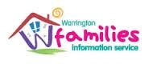 | Full details can be found at:  http://warrington.fsd.org.uk/kb5/warrington/fsd/home.page

