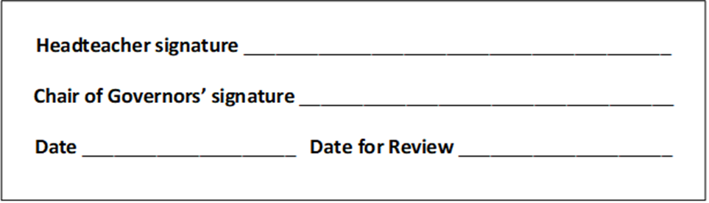
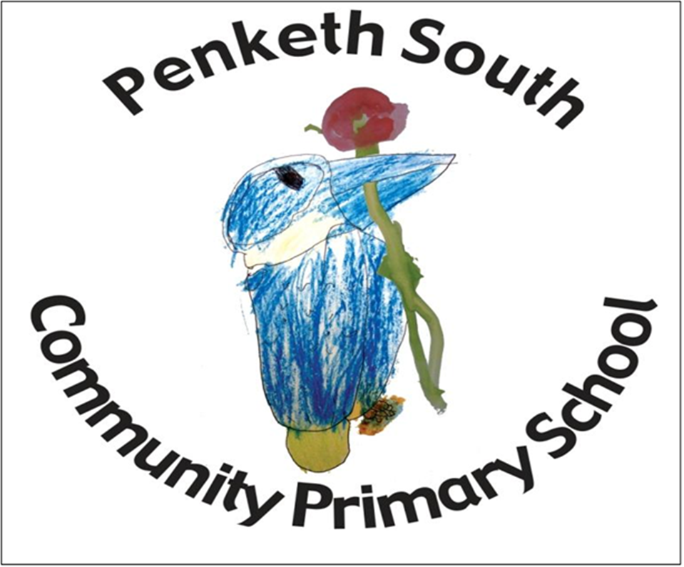
English Policy
“Do your best. Be your best.”

Curriculum Vision

On the children’s journey through Penketh South, we aim to spark their curiosity and fire their enthusiasm. We want our children to take pride in themselves, their achievements and their environment. They will be taught to respectfully question, to show appreciation for the world around them and to accept and understand equality and diversity. We will provide opportunities for our children to develop as independent, confident and successful learners who have high aspirations for the future. The children will be encouraged and supported to become resilient learners who understand that it is ok to make mistakes as long as they use these experiences to help them to develop and grow. Our children will become learners for life, powerful contributors, confident individuals and responsible citizens of the future.

English Curriculum Intent

“Literacy is the jump-off point from which all of life’s successes take flight”
Lauri Fortino
English is the foundation of our curriculum. It unites the life skills of reading, writing and oracy. The three elements work alongside each other to enable children to make sense of the world around them and understand the way language is used to communicate. At Penketh South, we want every child to be confident and fluent in expressing themselves through a variety of different means and develop English skills for life. We strive to create a community of readers and writers who use their English skills confidently and competently across all lessons. We hope to foster a love of language and text through our approach to teaching and learning.
We aim to provide the children at this school with a rich and stimulating language environment. Pupils will be given opportunities to become confident, competent, reflective and expressive users of language that interrelate the requirements of English within a broad and balanced approach across the curriculum.

Our Curriculum is designed to enable each pupil to:

- read and write with confidence, fluency and understanding, orchestrating a range of independent strategies to self-monitor and correct

- have an interest in books and read for enjoyment and information

- appreciate our rich and varied literary heritage

- have an interest in words and their meanings and to develop a growing vocabulary in spoken and written forms

- understand a range of text types and genres and to be able to write in a variety of styles and written forms

- have an awareness of purpose and audience for both written and oral awareness

- use discussion in order to learn; they should be able to elaborate and explain clearly their understanding and idea

- are competent in the arts of speaking and listening, making formal presentations, demonstrating to others and participating in debate.

- to develop the powers of imagination, inventiveness and critical awareness

- have suitable technical vocabulary to articulate suitable responses

- provide an environment where pupils are encouraged to construct and convey meaning, both in speech and writing of factual, imaginary and personal experiences

Curriculum Implementation

At Penketh South Primary School we are committed to the delivery of excellence in the teaching of English. We aim for each child to be able to read with fluency, understanding and enjoyment and to be able to communicate effectively both orally and in written form to any given audience. These skills are essential foundations for literacy development and the effective teaching of English will offer opportunities to promote these skills across the curriculum. Statutory requirements for the teaching and learning of English are laid out in The National Curriculum, 2014 and Early Years Framework, 2021

Early Years

In Early Years, we follow the educational programmes as set out in the Early Years Framework which provides children with appropriate transition into the National Curriculum. Literacy development involves encouraging children to link sounds and letters and to begin to read and write. Children are given access to a wide range of high-quality reading materials to ignite their interest and spark their curiosity. Communication and Language and Literacy are taught in Nursery and Reception as an integral part of the School’s curriculum.
We engage in high quality adult-led interactions to encourage, support and extend children’s speech and language development. We promote an ethos where listening to children’s ideas and feelings is important, where books are treated with respect and stimulate anticipation, and where children’s attempts at mark marking and early writing are valued and encouraged.
Children’s early reading is supported through enjoyable, fun learning opportunities. Our approach to the teaching of phonics is interactive and multisensory, where all pupils are actively involved in the learning of new sounds. We follow the Supersonic Phonics Friends programme which is a fully systematic, synthetic programme for teaching phonics skills. We ensure that the children have daily experience of action rhymes, songs and stories. We have a print rich environment with songs for children to read and an attractive book corner that houses a good range of stories, poetry and non-fiction books. Children are able to interact and recreate stories with props from Story Sacks and puppets. We model the process of reading and writing for children. For example, when preparing the following day’s cooking activity, we read the recipe and write a shopping list together for the ingredients we need.
Swirling scarves, painting with decorators’ brushes outside and stirring mixtures in cooking are amongst the activities to help develop children’s shoulder and arm movements for writing. Fine motor skills and hand-eye coordination are encouraged through finger rhymes, bead threading, pouring water in the tray and using tweezers to pick up small items. Opportunities for mark making are provided in sensory trays with soapy sand, gloop and finger paints. Emergent writing is encouraged through continuous provision e.g. in the shop, office, café, etc. where children are provided with a range of writing materials. Children are encouraged to write in role, such as lists, forms, menus, prices.

Key Stage 1

Children in Year 1 have daily phonics lessons following the Systematic Synthetic Programme “Supersonic Phonics Friends” with the aim to ensure children become fluent and speedy readers. They have daily English lessons in which a high-quality text is read as the vehicle for learning. Across the week children have opportunities to rehearse and develop the skills they need for writing in response to the text they have read, to respond imaginatively and to write for a range of purposes and audiences with technical accuracy. Some children in Year 2 have phonic lessons as an intervention, ideally up to three times a week.

Key Stage 2

In Key Stage 2, children have daily English lessons in which teachers aim to provide stimulating experiences and opportunities to motivate children to read and write by using a high-quality text as the vehicle for learning. There is a clear and progressive journey of learning across a unit in which children are given opportunities to develop and rehearse their learning and writing skills and knowledge. The journey builds up to children having the opportunity to write at greater length and across a wide variety of genres. Spelling is taught discretely to ensure children learn and apply rules and patterns to become confident and accurate spellers. Whereas, grammar and punctuation are taught within the context of the text and the genre being taught where possible.

The Strands

Oracy
At Penketh South we aim to encourage every child to listen attentively and communicate clearly in response aiming to be able to communicate confidently in ways which are appropriate to a range of audiences and purposes, using Standard English, body language and a wide range of vocabulary.

We will follow the guidelines in the curriculum where Spoken language has been identified separately and set out eleven broad statements which cover the expectations from Year 1 to Year 6.

It emphasises the importance of integrating and embedding the development of speaking and listening across the English and the wider curriculum. It also makes explicit links to the accurate use of grammar and the choice of appropriate vocabulary with the understanding and use of Standard English.

Spoken language and pupils skills in oracy underpin development and progression in both reading and writing.

We aim for pupils to be able to;

- use speech appropriately for different purposes

- adopt appropriate vocabulary, tone, pace and style for a variety of situations

- understand the effect on the listener

- use talk to develop and express ideas and communicate effectively

- follow verbal instructions accurately

- develop skills of turn-taking, negotiation and reaching consensus

- use role of ‘talking partners’ as a way of helping others in the learning process by sharing ideas and being supported

Reading

Reading is a vital form of communication for everyone. In developing the skill of reading, children gain access to and derive pleasure from rich and varied sources of literature and a wide variety of facts and figures contained within non-fiction. The ability to read and interpret the written language is a fundamental skill for accessing all other areas of the curriculum and is an essential life-long skill. Key to improving outcomes in all subjects is fostering a love of reading.
At Penketh South Primary there is focused and dedicated time given to the teaching of the mechanics of reading as well as opportunities for children to develop their love of reading. We strive to create a text-rich environment for all of our children which appeals to their interests and helps to create a love of reading. We ensure that children have access to a wide range of diverse texts which not only inspire and excite them, but also enable them to broaden their knowledge.

At Penketh South we provide the children with regular opportunities to apply their phonics knowledge when reading a carefully selected book for the school's banded book scheme. Staff will listen to each child in Reception and KS1 read every week. In EYFS early comprehension skills are taught during story time sessions and when the children are in provision through the use of high quality texts. In KS1 reading is taught primarily through whole-class reading and one to one reading time.
In KS2, Reading is primarily taught through whole-class reading although it is integrated into all of our curriculum. We believe that teaching the whole class allows the teacher to develop a shared love for reading, raise expectations and experiences for all children and better prepare children to meet age related expectations. Some children receive additional intervention outside of the whole class reading sessions to enable them to make accelerated progress. Children are exposed to high quality literature texts encompassing fiction, non-fiction and poetry. In KS2, the children have a home reading book which they can choose from a selection within their own reading level.

We believe it is key that parents play a big part in their child’s reading process and encourage them to listen to their child read regularly at home. Children have a reading book available in school, at home and a reading record is sent home. These reading records are an important way for teachers to communicate the child’s progress in reading to parents. Children are expected to read at least three times per week. The parents and children are encouraged to comment in the reading record book. To support parents at home we have provided for EYFS and KS1 parents reading bookmarks. These come with questions parents could use to engage with their child. We support parents in reading with their child through our website as well.

The teaching of reading will include:
• the teaching of phonic awareness
• questioning about character/ story/ events/ structure/ plot
• awareness of layout / features
• awareness of punctuation
• prediction of the story
• developing decoding skills of unfamiliar words
• awareness of the reading and spelling of common exception words/ tricky words
• deduce meaning from context, syntax and previous experience
• scanning text for information and to support comprehension
• discussing the effectiveness of chosen language
• encouraging talk and discussion in groups.
• encouraging clear speaking and expression when reading texts aloud
• allowing opportunities for children to read for sustained lengths of time

Every class will have access to a stimulating and inviting reading area that encourages children to come and read a variety of fiction and non-fiction texts reflecting genres, cultures, gender and race. A respect for books will be fostered and modelled by all staff and children. Every class will have a ‘class book’ – a quality novel / story that is read regularly for the enjoyment of ‘listening’. Parents are invited into school as volunteers to read with the children. Parents are also invited to Reading Cafe sessions where they have the opportunity to spend some time. Furthermore, we regularly send out Reading Newsletter to encourage parents and children to engage more with reading. Every Friday, our Reading Book Bags are being sent home with one child per class. Teachers carefully choose a selection of books to send home with a child for the weekend. This supports and strengthens the importance we have in Reading. The parents are also provided with a range of reading support for their child on the school website and in Early Years and KS1 through a reading bookmark.

Writing

At Penketh South our aim is for children to write clearly, accurately and coherently, adapting their language and style in and for a range of contexts, purposes and audiences. We want pupils to acquire a wide vocabulary, a solid understanding of grammar and be able to spell new words by effectively applying the spelling patterns and rules they learn throughout their time in primary school. We believe that all pupils should be encouraged to take pride in the presentation of their writing, in part by developing a good, joined, handwriting style by the time they move to secondary school. All good writers refine and edit their writing over time, so we want children to develop independence in being able to identify their own areas for improvement in all pieces of writing, editing their work effectively during and after the writing process. We do not put ceilings on what pupils can achieve in writing and we do not hold pre-conceptions about any pupils’ ability to make progress.

We use when available Focus Sow for writing to support the teaching of writing from Year 1 through to Year 6. Through this, children engage with a wide range of quality model texts and therefore build a knowledge of different genres of writing that they can apply in a variety of circumstances. We want children to acquire an interest and excitement in words and their meanings, enriching their expressive language use and enhancing their vocabulary. Our goal is to inspire children’s imagination and ignite their curiosity, opening the door to a lifelong enjoyment of literature and language.
We teach English as whole class lessons, so that all children have access to the age-related skills and knowledge contained in the National Curriculum. Within lessons, teachers and teaching assistants target support for children who need it to enable them to achieve at an age-related level wherever possible. This may involve a greater level of scaffolding and access to additional support materials such as word banks or a greater level of modelling. High attaining children are given opportunities to extend their writing in a variety of ways, including through showing greater control in their writing, a deeper understanding of the impact that their writing has on the reader and by using a higher level of vocabulary and grammar features.
Grammar and punctuation knowledge and skills are taught through English lessons as much as possible. Teachers plan to teach the required skills through the genres of writing that they are teaching, linking it to the genre to make it more connected with the intended writing outcome. Teachers sometimes focus on particular grammar and punctuation skills as stand alone lessons if they feel that the class needs additional lessons to embed and develop their understanding or to consolidate skills.
Each year group use the National Curriculum to ensure they have full coverage of each of the writing genres.
Handwriting
It is important for pupils to be able to write clearly and develop a fluent and legible handwriting style. The school will use Letterjoin Handwriting scheme to allow for progression and continuity. Children will be given discrete handwriting lessons and time to practice to:
- form letters correctly

- use upper case and lower case letters appropriately

- begin to join writing from Year 2 once letters are correctly formed

- use a correct and comfortable pencil/pen grip

Spelling
From Year 2 onwards we follow The Spelling Book approach from Jane Considine. It is an effective way to build a spelling curriculum that focuses on the teaching of spelling, ensuring a drive on the ‘Big Mission’ for all pupils. That ‘Big Mission’ is what Jane Considine describes as spelling ’stickability’, automation and application into the pupils’ independent writing. An essential trait of literate people is being able to spell effectively and spelling is valued in society above all other writing conventions (Turnbill, 2000).
It is a fully comprehensive approach that targets reading patterns of spelling, the pressures of spelling and the remembering of spelling It is a system that is based in strong phonics teaching with a focus on teaching pupils the connections between words, their sound associations, etymology and patterns.
Teachers are guided through the rationale and approaches to ensure that they have a deep understanding of the processes they can follow to become more effective teachers of spelling. Pupils will extend their knowledge of phonics throughout their time in primary school. They will improve their outcomes as they develop a culture of becoming ‘pattern finders’ and ‘spelling detectives’ instead of being demotivated by the repetitive failure of the weekly ’spelling test’ and they will acquire a range of strategies to apply during real-life composition of writing.
It is a way of teaching spelling that relies on teachers to bring the ‘wonder of words’ to life. The Spelling Books provide structure and support to teachers whilst allowing enough room for creativity, ensuring that all National Curriculum fundamentals are covered.
English across the Curriculum
English is cross-curricular in nature. Speaking and listening, reading and writing are an integral part of all other areas of the curriculum. Specific skills can be transferred from literacy and developed in science. Chronological writing can be used in history to develop sequenced information as instructional writing can be used in Design and Technology. This awareness of text and language features will be developed in literacy then transferred into other areas of the curriculum. We expect writing in Foundation subjects to be the same quality as in English.

Progression, Balance and Breadth

Careful planning assures balance, coverage and progression throughout each academic year and year on year. It is important that pupils have opportunities to learn and revise the skills necessary for new progress. Real-life contexts must be created for learning and once learnt, skills need to be applied and integrated in other areas of the curriculum so that they do not become isolated. English is paramount in the teaching of other subjects in the primary curriculum.

The school will ensure that:

All children will cover the content of study within the English Curriculum. Children will access the curriculum at the appropriate level to ensure progression and differentiation. Suitable resources and learning environments will be available to enable children access to the learning required. We provide learning opportunities that are matched to the needs of children with special needs and those learning English as an additional language.

S.E.N.D

Pupils with special needs are supported by differentiated learning strategies based on individual needs. Support is usually given in class but sometimes groups or individuals are withdrawn for a particular focus e.g. intervention programmes and Precision Teaching

Parents will be kept informed and encouraged to assist in helping with their children. Support staff should be involved with the planning, assessing and recording of targets achieved by any pupil under their supervision.

Equal Opportunities

Equal opportunities in English are addressed as follows:

- Pupils with special needs have equal access to the English curriculum through the use of differentiated learning strategies and tasks. These are based on individual needs.

- Respect for cultural and linguist diversity is promoted through the use of resources on multi-cultural themes.

- An awareness of other dialects and standard English encouraged through using a range of texts.

- Gender equality is promoted by ensuring that both boys and girls have access to all aspects of the English curriculum.

- Opportunities to address issues of gender, race etc are provided through discussion, texts and resources.

Curriculum Impact

The agreed programme of work will ensure continuity, progression and differentiation. The whole school approach to long, medium and short-term planning for English reflects the recommendations and statutory requirements of the National Curriculum. Assessment is ongoing and informs future planning; it is in line with the guidelines set out in the School’s assessment policy.

Assessment and Recording

Teachers assess children’s work in English in three phases. The short-term assessments that teachers make as part of every lesson help teachers to adjust their daily plans. Teachers match these short-term assessments closely to the teaching objectives. They use medium-term assessments to measure progress against the key objectives, and to help them plan for the next unit of work. Teachers make long-term assessments towards the end of the school year, and they use these to assess progress against school and national age-related expectations. With the help of these long-term assessments, teachers are able to set targets for the next school year and summarise the progress of each child before discussing it with the child’s parents. The next teacher also uses these long-term assessments as the basis for planning work for the new school year. These long-term assessments are made using a range of test materials and teacher assessments. Children undertake the national tests at the end of Year 2 and Year 6. Teachers also make annual assessments of children’s progress using age-related expectations that are set out in the National Curriculum. Teachers meet regularly to moderate samples of work using the TAFs and the TCAT moderation sheets. Writing outcomes are validated internally and externally via TCAT schools. Writing can be externally moderated by the Local Authority in Year 2 and Year 6.
There are planned assessments that take place through the year for Reading using NFER and the national tests for Year 2 and Year 6. PM Benchmark is used to support a teacher to ascertain if a child is ready to move up through the school book banded system.

Monitoring and Review
Monitoring of the standards of the children’s work and of the quality of teaching in English is the responsibility of the English subject leaders and Senior Leadership Team. The work of the subject leaders also involves supporting colleagues in the teaching of English, being informed about current developments in the subject, and providing a strategic lead and direction for the subject in the school. The English governor provides the link between the governing body and the staff, through asking questions about current policy and practice. As well as being invited to attend any English INSET training, the English governor should;

- Meet with the subject leaders to discuss progress and become informed about school English issues

- Be given the opportunity to visit classrooms to observe an English lesson

- Report to the governing body/committee as agreed

